## InputStream class

InputStream class is an abstract class. It is the super class of all classes representing an input stream of bytes. InputStream Hierarchy

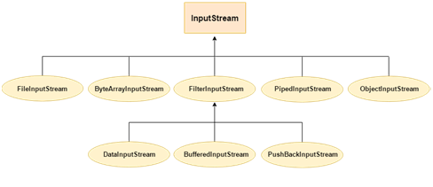

### Useful methods of InputStream

|  |  |
| --- | --- |
| **Method** | **Description** |
| 1) public abstract int read()throws IOException | reads the next byte of data from the input stream. It returns -1 at the end of file. |
| 2) public int available()throws IOException | returns an estimate of the number of bytes that can be read from the current input stream. |
| 3) public void close()throws IOException | is used to close the current input stream. |